MINN2020A: Computer Programming for Mining
Mining Health, Safety and Equipment Monitoring Application
Section A: Access Control and Section B: Worker Health and Safety Monitoring
This document gives the algorithms, pseudocode and flowcharts for Sections A and B. The corresponding Python files are auth.py for Section A and worker_safety.py for Section B. The tests are in test_sections_a_b.py. The thresholds used in Section B are only prototype values for this assignment and are not actual mine or manufacturer safety limits.

Section A: Access Control

A.1 Algorithm
Login
- Start.
- Enter the username and password.
- If either field is empty, display an error and ask the user to try again.
- Load the users file and find the entered username.
- If the username is not found or the account is disabled, display 'Invalid username or password' and ask again.
- Hash the entered password using the user's stored salt and compare it with the stored hash. If they do not match, display 'Invalid username or password' and ask again.
- Store the username and role in the session, then allow access to the pages for that role.
- End.
Permission check (role-based access control)
- Start when a user tries to open a page that requires a specific function, such as 'Equipment data'.
- If the user is not logged in, display 'Please log in' and stop.
- Find the function in the PERMISSIONS table, which is based on Table 1 in the brief.
- If the user's role is not allowed for that function, display 'Access denied' and stop.
- If the role is allowed, display the page.
- End.
User management (Administrator only)
- Start. Only an Administrator can open this page because of the permission check above.
- For a new user, enter the username, password and role.
- Check that the username contains only letters and numbers and is not already in use. Check that the password has at least 8 characters, including a letter and a digit, and that the selected role is one of the five valid roles.
- Generate a random salt, hash the password and save the new user as active.
- Before disabling or deleting a user, check that the user exists. An administrator cannot disable or delete their own account, and the last active administrator cannot be deleted.
- Display a success or error message after each action.
- End.

A.2 Pseudocode
FUNCTION hash_password(password, salt)
IF salt is not given THEN salt <- random 16 bytes
hash <- PBKDF2-HMAC-SHA256(password, salt, 100000 repetitions)
RETURN salt, hash
END FUNCTION

FUNCTION authenticate(username, password)
username <- trim and lowercase(username)
IF username is empty OR password is empty THEN
RETURN False, 'Please enter both username and password'
END IF
user <- users[username]
IF user not found OR user is disabled THEN
RETURN False, 'Invalid username or password'
END IF
IF hash_password(password, user.salt) <> user.hash THEN
RETURN False, 'Invalid username or password'
END IF
RETURN True, user.role
END FUNCTION

FUNCTION has_permission(role, function)
IF function is not in PERMISSIONS THEN RETURN False
IF role is in PERMISSIONS[function] THEN RETURN True
RETURN False
END FUNCTION

FUNCTION require_permission(function)
IF user is not logged in THEN
DISPLAY 'Please log in'
STOP
END IF
IF NOT has_permission(session role, function) THEN
DISPLAY 'Access denied'
STOP
END IF
CONTINUE to the page
END FUNCTION

FUNCTION add_user(username, password, role)
username <- trim and lowercase(username)
IF username has anything except letters and digits THEN RETURN error
IF username already exists THEN RETURN error
IF length(password) < 8 THEN RETURN error
IF password has no letter OR no digit THEN RETURN error
IF role is not in ROLES THEN RETURN error
salt, hash <- hash_password(password)
SAVE user {salt, hash, role, active = True}
RETURN success message
END FUNCTION

FUNCTION set_user_active(username, active, acting_user)
IF username not found THEN RETURN error
IF username = acting_user AND active = False THEN
RETURN error 'you cannot disable your own account'
END IF
user.active <- active
SAVE users
RETURN success message
END FUNCTION

FUNCTION delete_user(username, acting_user)
IF username not found THEN RETURN error
IF username = acting_user THEN RETURN error
IF user is Administrator AND active administrators <= 1 THEN RETURN error
REMOVE user and SAVE users
RETURN success message
END FUNCTION

MAIN (login page)
DISPLAY login form
READ username, password
ok, result <- authenticate(username, password)
IF ok THEN
SAVE username and role in the session
OPEN the pages allowed for that role
ELSE
DISPLAY result as an error and ask again
END IF
END MAIN

A.3 Permission table (Table 1 of the brief)
Function | Administrator | Safety Officer | Mining Engineer | Maintenance Engineer | Manager
View dashboard | Yes | Yes | Yes | Yes | Yes
Worker safety data | Yes | Yes | Yes | - | Yes
Safety incidents | Yes | Yes | Yes | - | Yes
Equipment data | Yes | - | Yes | Yes | Yes
Maintenance data | Yes | - | Yes | Yes | Yes
Risk assessment | Yes | Yes | Yes | - | Yes
Generate reports | Yes | Yes | Yes | Yes | Yes
Manage users | Yes | - | - | - | -

A.4 Flowcharts
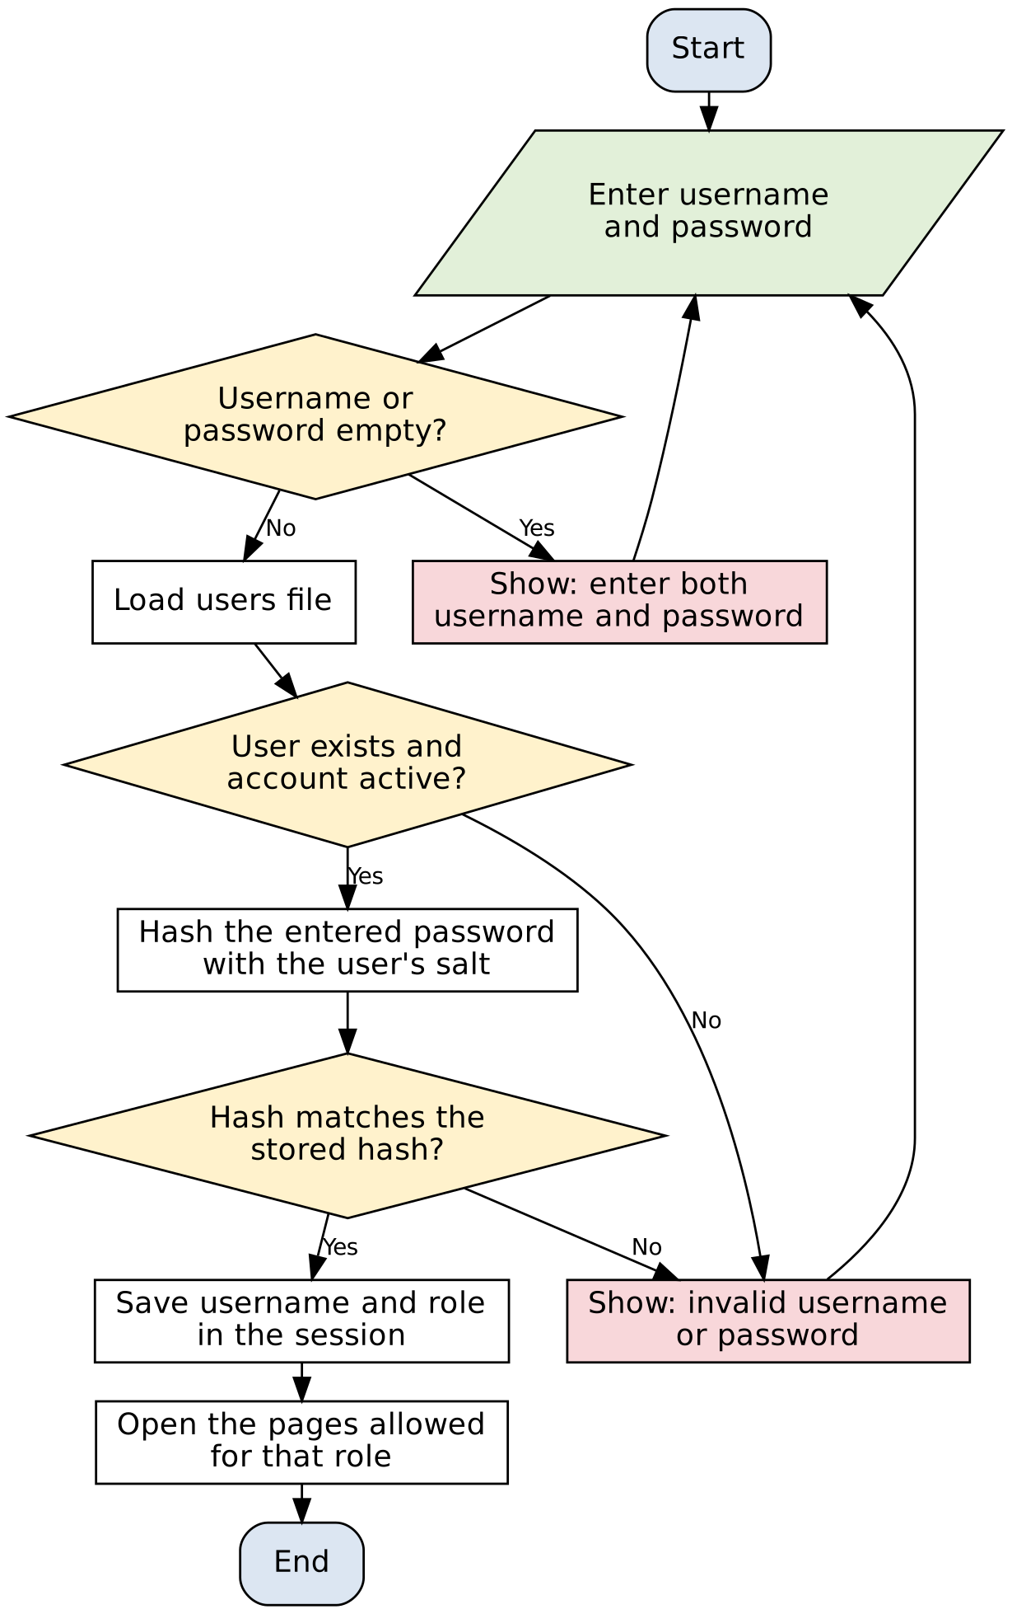
Figure A1: Flowchart for the login function
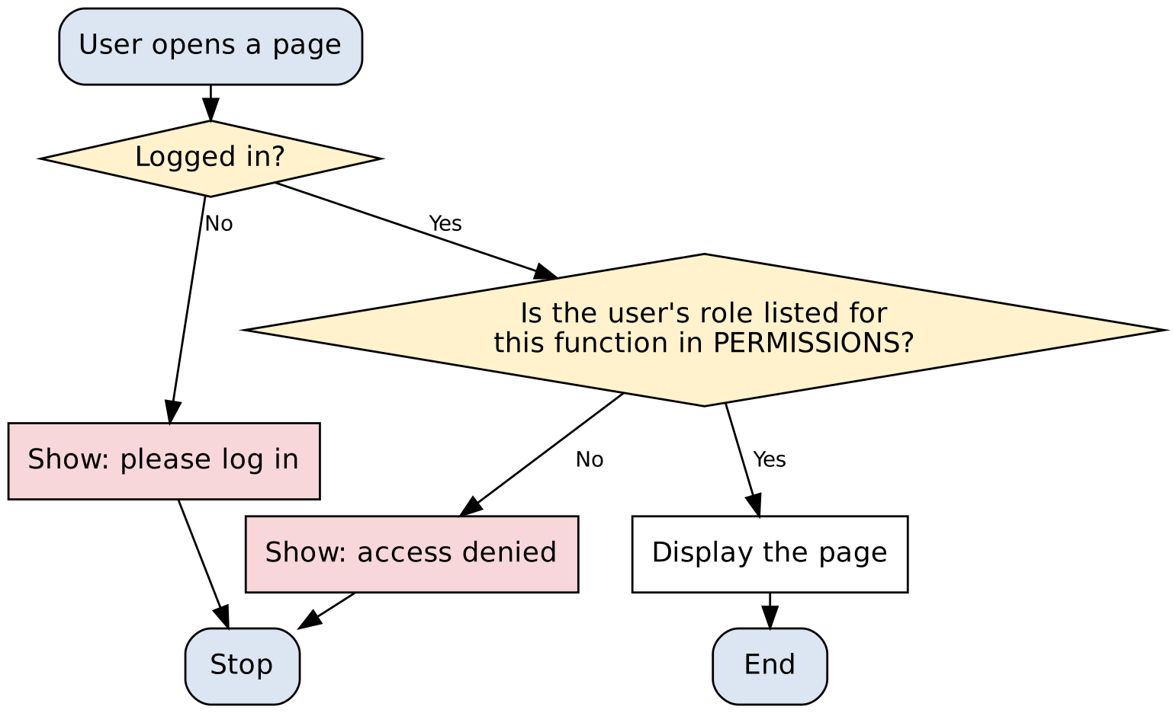
Figure A2: Flowchart for the permission check
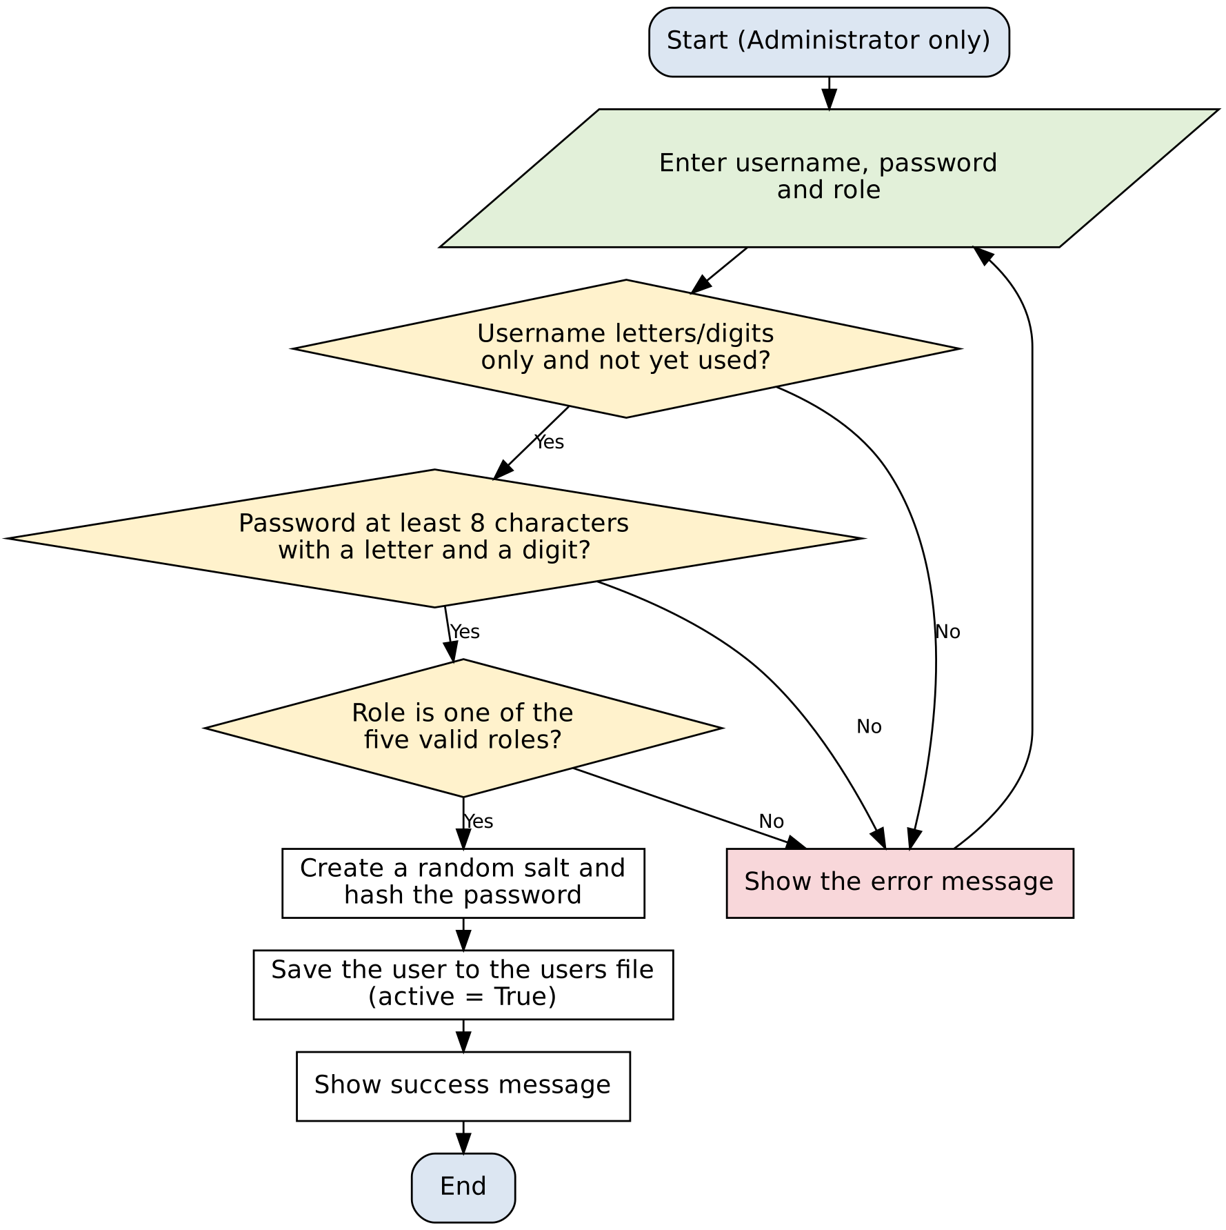
Figure A3: Flowchart for adding a user
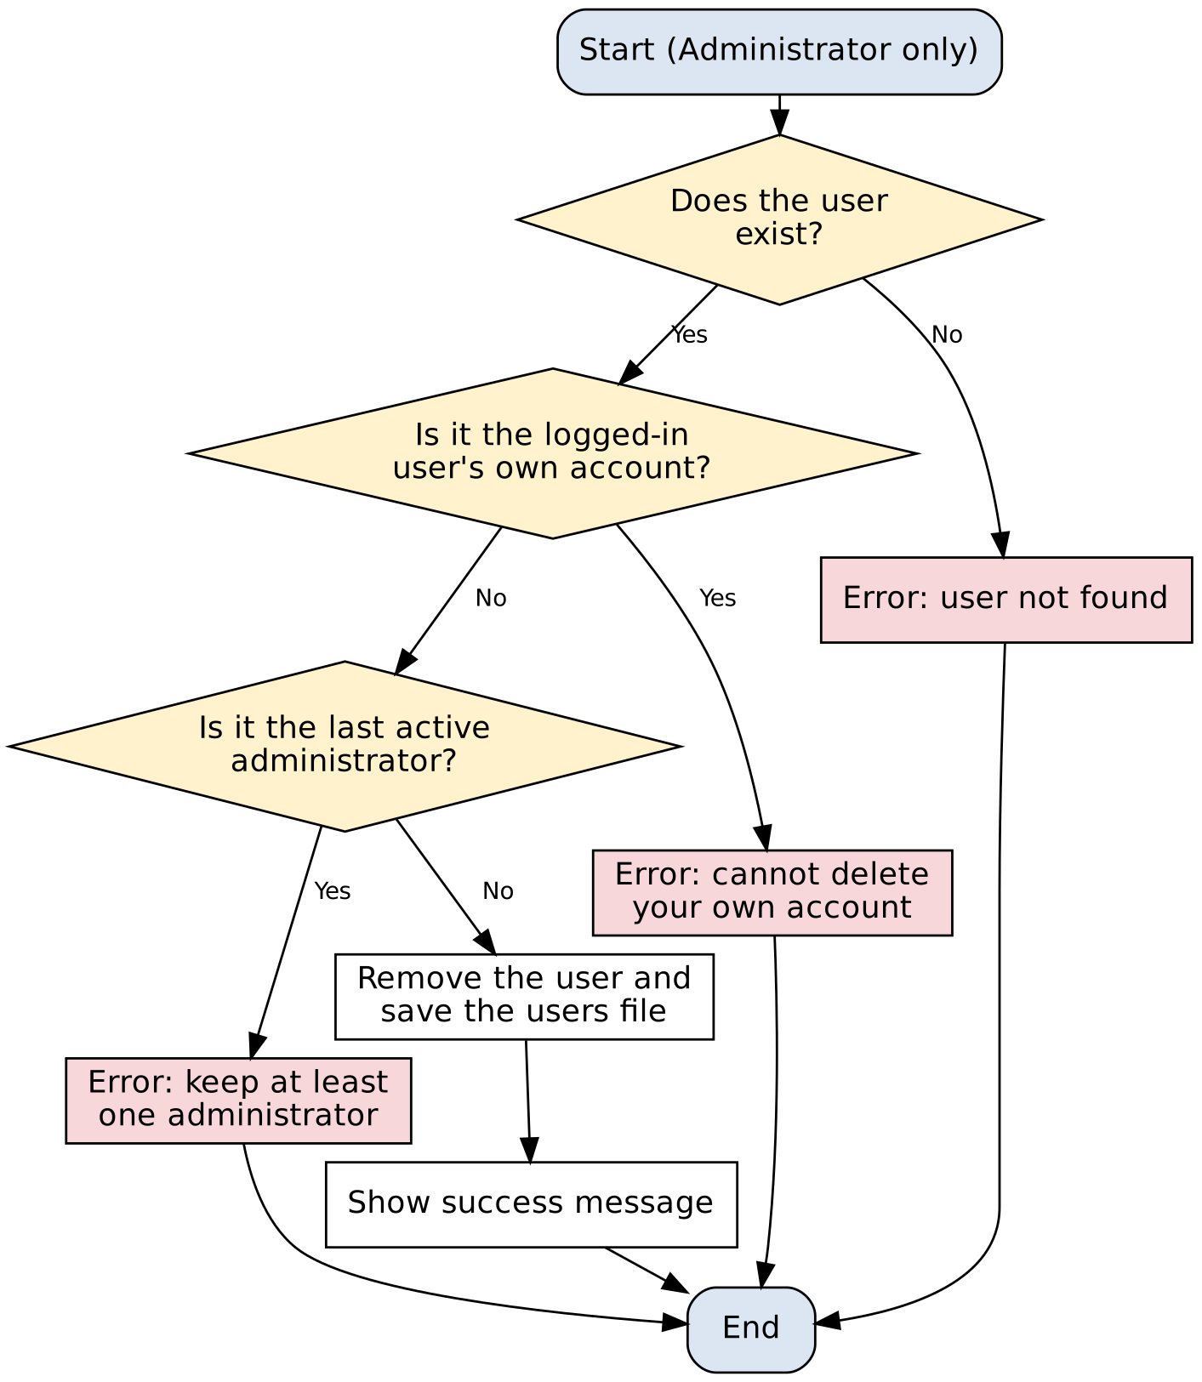
Figure A4: Flowchart for deleting a user

Section B: Worker Health and Safety Monitoring

B.1 Safety rules used (prototype thresholds)
Check | Warning | Critical | Source field
PPE compliance | Below 90 % | Below 75 % | PPE Compliance (%)
Fatigue level | 6 to 7 (scale 1 to 10) | 8 or more | Fatigue Level
Safety training | Due soon | Expired | Training Status
Previous incidents | 1 or 2 | 3 or more | Previous Incidents
Near misses | 2 or more | - | Near Misses
Safety observations | 3 or more | - | Safety Observations

The brief does not provide limits for the worker safety data, so the thresholds below are prototype values chosen for this project. They are stored as constants in worker_safety.py so that they can be changed easily.
Each WARNING adds 1 point and each CRITICAL warning adds 3 points. The final number of points is then used to set the worker's risk level.
Total points | Risk level
0 to 1 | Low
2 to 3 | Medium
4 to 5 | High
6 or more | Critical

B.2 Algorithm
Adding and assessing a worker
- Start.
- Enter the worker ID, department, job role, shift, PPE compliance, training status, fatigue level, safety observations, near misses and previous incidents.
- Check the input first. The worker ID must be entered and must not already exist. Department, shift and training status must be valid choices. PPE compliance must be between 0 and 100, fatigue must be between 1 and 10, and the three count fields must be whole numbers of 0 or more. If there is an error, display it and ask for the input again.
- Set points to 0 and create an empty list of warnings.
- Compare PPE compliance, fatigue, training status, previous incidents, near misses and safety observations with the rules in B.1. For each rule that is triggered, add the relevant WARNING or CRITICAL message and the corresponding points.
- Use the total points to set the risk level: 6 or more is Critical, 4 to 5 is High, 2 to 3 is Medium, and 0 to 1 is Low.
- Add the worker and risk level to the workers table, then save the data to workers.csv.
- Show a message confirming that the worker was saved, together with any CRITICAL and WARNING messages.
- End.
Viewing, searching and filtering workers
- Start by loading the workers and recalculating each worker's risk level.
- If search text is entered, keep only the rows where that text appears in one of the columns.
- Apply the department, shift, risk level and training-status filters. If a filter is set to 'All', do not apply that filter.
- Display the worker table together with the summary values: total workers, average PPE compliance, near misses, high-risk workers, expired training and high fatigue.
- Show all CRITICAL warnings on the Alerts tab. If there are none, display 'No critical worker safety alerts'.
- End.

B.3 Pseudocode
FUNCTION validate_worker(record, existing_ids)
errors <- empty list
IF worker_id is empty THEN add error
ELSE IF worker_id is in existing_ids THEN add error
END IF
IF department is not in DEPARTMENTS THEN add error
IF job_role is empty THEN add error
IF shift is not in SHIFTS THEN add error
IF ppe is not a number OR ppe < 0 OR ppe > 100 THEN add error
IF training_status is not in TRAINING_STATUSES THEN add error
IF fatigue is not a number OR fatigue < 1 OR fatigue > 10 THEN add error
FOR EACH of observations, near_misses, previous_incidents
IF value is not a whole number OR value < 0 THEN add error
END FOR
RETURN errors
END FUNCTION

FUNCTION assess_worker(record)
warnings <- empty list
points <- 0
IF ppe < 75 THEN add CRITICAL warning; points <- points + 3
ELSE IF ppe < 90 THEN add WARNING; points <- points + 1
END IF
IF fatigue >= 8 THEN add CRITICAL warning; points <- points + 3
ELSE IF fatigue >= 6 THEN add WARNING; points <- points + 1
END IF
IF training_status = 'Expired' THEN add CRITICAL warning; points <- points + 3
ELSE IF training_status = 'Due soon' THEN add WARNING; points <- points + 1
END IF
IF previous_incidents >= 3 THEN add CRITICAL warning; points <- points + 3
ELSE IF previous_incidents >= 1 THEN add WARNING; points <- points + 1
END IF
IF near_misses >= 2 THEN add WARNING; points <- points + 1
IF observations >= 3 THEN add WARNING; points <- points + 1
IF points >= 6 THEN level <- 'Critical'
ELSE IF points >= 4 THEN level <- 'High'
ELSE IF points >= 2 THEN level <- 'Medium'
ELSE level <- 'Low'
END IF
RETURN level, warnings
END FUNCTION

FUNCTION add_worker(record)
workers <- load workers.csv
errors <- validate_worker(record, IDs in workers)
IF errors is not empty THEN RETURN False, errors
record.risk_level <- assess_worker(record)
ADD record to workers
SAVE workers.csv
RETURN True, 'Worker saved'
END FUNCTION

FUNCTION search_workers(workers, text)
IF text is empty THEN RETURN workers
RETURN rows where text is found in any column (ignore upper/lower case)
END FUNCTION

FUNCTION filter_workers(workers, department, shift, risk_level, training)
FOR EACH selected filter
IF filter is not 'All' THEN
workers <- rows where the column equals the selected value
END IF
END FOR
RETURN workers
END FUNCTION

FUNCTION summary_stats(workers)
IF workers is empty THEN RETURN all zeros
total <- number of rows
average_ppe <- mean of PPE compliance
near_misses <- sum of near misses
high_risk <- number of rows with risk level High or Critical
expired <- number of rows with training status Expired
high_fatigue <- number of rows with fatigue >= 6
RETURN total, average_ppe, near_misses, high_risk, expired, high_fatigue
END FUNCTION

MAIN (worker safety page)
workers <- load workers.csv and recalculate every risk level
DISPLAY summary_stats(workers)
READ search text and filters
DISPLAY filter_workers(search_workers(workers, text), filters)
FOR EACH worker
FOR EACH CRITICAL warning from assess_worker DISPLAY alert
END FOR
END MAIN

B.4 Flowcharts
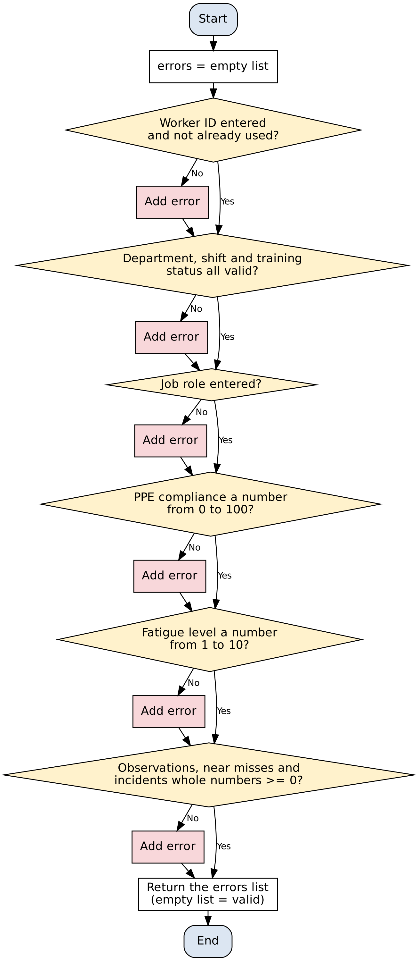
Figure B1: Flowchart for validating a worker record
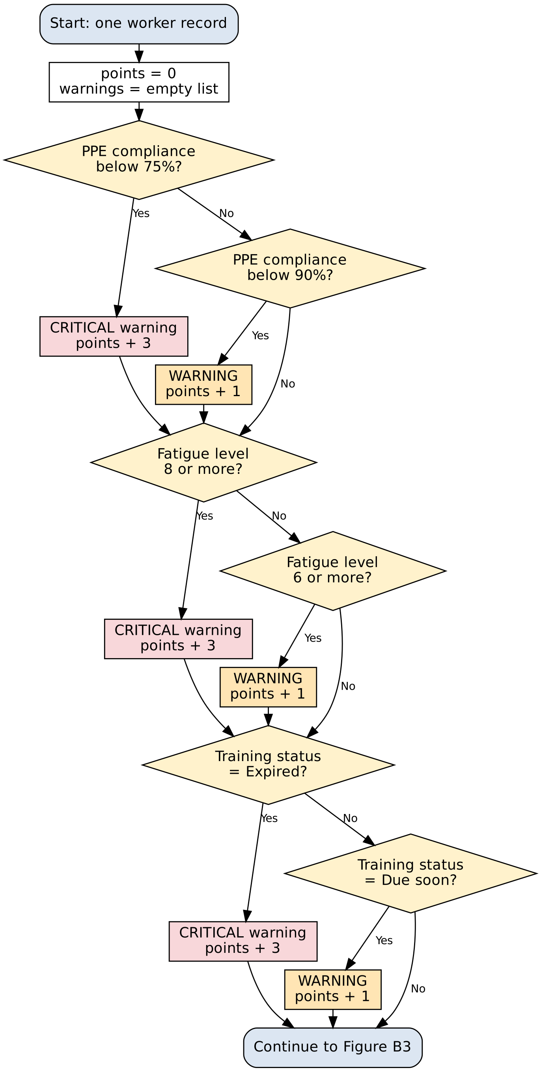
Figure B2: Flowchart for assessing a worker (part 1: PPE, fatigue, training)
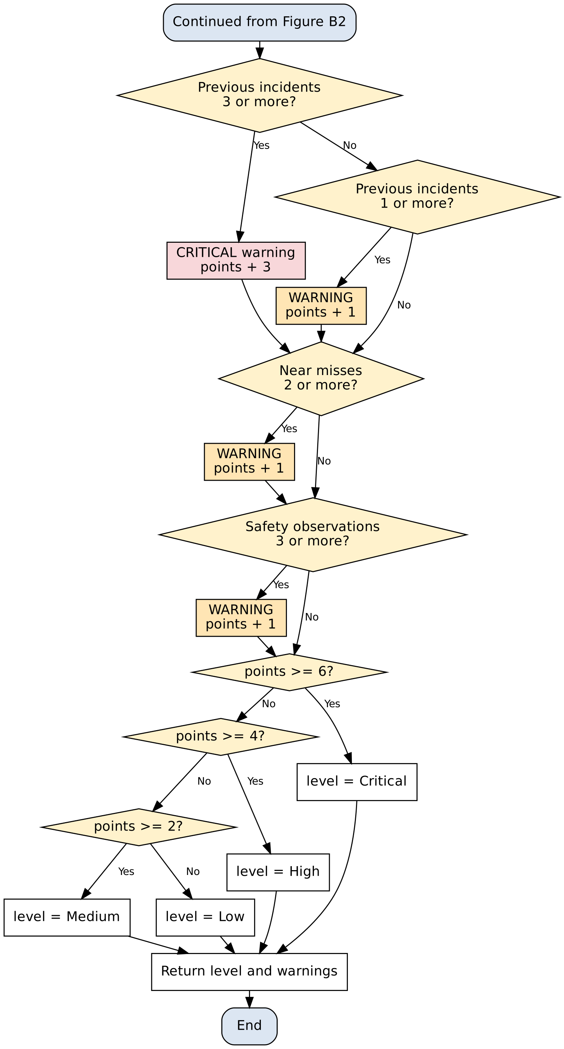
Figure B3: Flowchart for assessing a worker (part 2: incidents, near misses, observations, risk level)
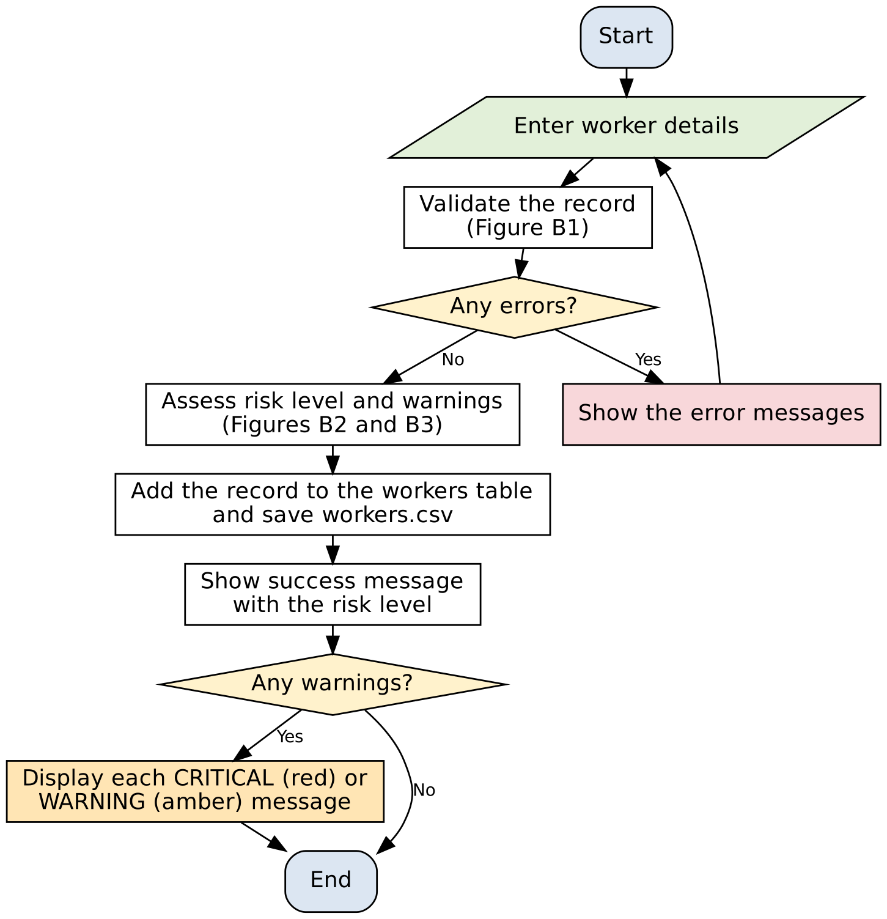
Figure B4: Flowchart for adding a worker
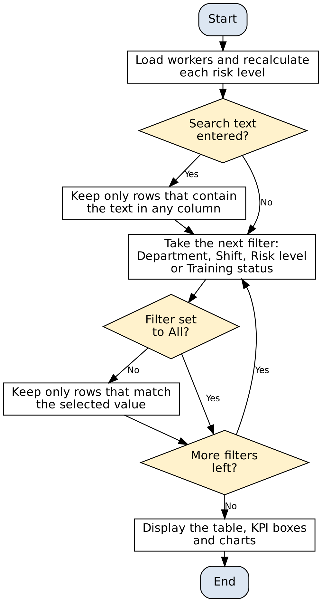
Figure B5: Flowchart for searching and filtering workers

Testing summary
The test_sections_a_b.py file contains more than 40 automated tests, and all of the tests pass.
- The login tests cover a correct password, a wrong password, an unknown user, empty fields and a disabled account.
- The permission tests check the main rules in Table 1, including the Maintenance Engineer restriction on worker safety data and the Administrator-only user management. They also check dashboard and report access and reject an unknown function.
- The user-management tests cover duplicate usernames, invalid usernames, weak passwords, invalid roles, an administrator trying to delete their own account and an attempt to delete the last administrator.
- The worker-validation tests include PPE above 100, non-numeric PPE, fatigue of 0, negative counts, an invalid shift, an empty worker ID and a duplicate ID.
- The risk-rule tests check a safe worker, a worker who triggers several rules, and the boundary values for PPE compliance and fatigue.
- The saving and searching tests check saving a worker, rejecting a duplicate, loading the data again from the CSV file, text searching, shift filtering and summary statistics when the table is empty.
To run the tests, place auth.py, worker_safety.py and test_sections_a_b.py in the same folder and run: python test_sections_a_b.py

